**MOHANLAL SUKHADIA UNIVERSITY**

**University College of Science**

**Udaipur, Rajasthan – 313001**



**MIJOR PROJECT REPORT ON**

**"Collegespace "**

Submitted in partial fulfillment of the requirements for

**MAJOR PROJECT [BCAS-503] IN**

**6th SEM BACHELOR OF COMPUTER APPLICATIONS 2022-2023**

**Submitted by: Mohammad Imran**

**Submitted to: Ronak Taldar**

**DECLARATION**

I hereby declare that this project work entitled “College Space ” has been prepared by me during the year 2022 -23 under the guidance of Mr. , Department of Computer Science, Mohanlal Sukhadia University, Udaipur in the partial fulfillment of Major Project BCA 6th Semester degree prescribed by the college.

I also declare that this project is the outcome of my own effort, that it has not been submitted to any other university for the award of any degree.

Date: 30-09-2022

**ACKNOWLEDGEMENT**

I consider it a privilege to whole-heartedly express my gratitude and respect to each and every one who guided and helped me in the successful completion of this Project Report.

I am very thankful to the course director **Dr. Avinash Panwar** for being kind enough to provide me an opportunity to work on a Project in this institution.

I would greatly mention the enthusiastic influence provided by

**Ronak Sir,** as my Project Guide, for his ideas and co-operation showed on me during my venture and making this Project a great success.

I would also like to thank my parents and well-wishers as well as my dear classmates for their guidance and their kind co-operation.

Finally, it is my pleasure and happiness to the friendly co-operation showed by all the staff members of Computer Science Department, UCOS, MLSU.

**PREFACE**

The project report is prepared for the minor project completed during the course of BCA 5th Semester undertaken at UCOS, as a part of the BCA 5th Semester curriculum as prescribed by MLSU, Udaipur.

The purpose of this report is to assemble under one cover a sufficient body of knowledge about management and development of a successful project. This report assembles various functions like planning, organizing, designing, testing, and maintenance of the “College Space ” used during the development of the project.

College Space is an online information website for regular college students. This website provides us Notes and information related to Admission and Examination to make student life more Convinient.

This website also provide user with information about latest technology updates, new software. The user can directly access all articles from the website. The admin have the ability to edit the Articles, insert new ones. Website give information about the recent updates of the university regularly.

This website also contains all the information about the holidays declared by the university and the government

**TABLE OF CONTENTS**

1. Introduction
   1. Introduction about the project
   2. Aim and Objectives
2. Technologies Used
   1. Front End Technology
   2. Back End Technology
3. System Analysis and System Study
   1. Information Gathering
   2. Feasibility Study
4. System Design
   1. Data Dictionary
   2. Data Flow Diagram
   3. Use Case Diagram
   4. ER Diagram
   5. Project Snapshot
   6. Database Screenshot
5. Mechanisms Used
   1. Testing Mechanisms
6. Future Scope of the Project
7. Bibliography and references

**1. INTRODUCTION**

A blog (a truncation of "weblog") is a discussion or informational website published on the World Wide Web consisting of discrete, often informal diary-style text entries (posts). Posts are typically displayed in reverse chronological order, so that the most recent post appears first, at the top of the web page. Until 2009, blogs were usually the work of a single individual,[citation needed] occasionally of a small group, and often covered a single subject or topic. In the 2010s, "multi-author blogs" (MABs) emerged, featuring the writing of multiple authors and sometimes professionally edited. MABs from newspapers, other media outlets, universities, think tanks, advocacy groups, and similar institutions account for an increasing quantity of blog traffic. The rise of Twitter and other "microblogging" systems helps integrate MABs and single-author blogs into the news media. Blog can also be used as a verb, meaning to maintain or add content to a blog.

The emergence and growth of blogs in the late 1990s coincided with the advent of web publishing tools that facilitated the posting of content by non-technical users who did not have much experience with HTML or computer programming. Previously, a knowledge of such technologies as HTML and File Transfer Protocol had been required to publish content on the Web, and early Web users therefore tended to be hackers and computer enthusiasts. In the 2010s, the majority are interactive Web 2.0 websites, allowing visitors to leave online comments, and it is this interactivity that distinguishes them from other static websites. In that sense, blogging can be seen as a form of social networking service. Indeed, bloggers not only produce content to post on their

blogs but also often build social relations with their readers and other bloggers. However, there are high-readership blogs which do not allow comments.

Many blogs provide commentary on a particular subject or topic, ranging from philosophy, religion, and arts to science, politics, and sports. Others function as more personal online diaries or online brand advertising of a particular individual or company. A typical blog combines text, digital images, and links to other blogs, web pages, and other media related to its topic. The ability of readers to leave publicly viewable comments, and interact with other commenters, is an important contribution to the popularity of many blogs. However, blog owners or authors often moderate and filter online comments to remove hate speech or other offensive content. Most blogs are primarily textual, although some focus on art (art blogs), photographs (photoblogs), videos (video blogs or "vlogs"), music (MP3 blogs), and audio (podcasts). In education, blogs can be used as instructional resources; these are referred to as edublogs. Microblogging is another type of blogging, featuring very short posts.

'Blog' and 'blogging' are now loosely used for content creation and sharing on social media, especially when the content is long-form and one creates and shares content on regular basis. So, one could be maintaining a blog on Facebook or blogging on Instagram.

On February 16, 2011, there were over 156 million public blogs in existence. On February 20, 2014, there were around 172 million Tumblr and 75.8 million WordPress blogs in existence worldwide. According to critics and other bloggers, Blogger is the most popular blogging service used today. However, Blogger does not offer public statistics.Technorati lists 1.3 million blogs as of February 22, 2014.

**2. TECHNOLOGIES USED**

**2.1 Front-End Technology**

1. **HTML**

* HTML stands for Hypertext Markup Language.
* HTML is the standard markup language for creating web pages.
* HTML describes the structure of a Web page.

1. **CSS**

* CSS stands for Cascading Style Sheets.
* CSS describes how HTML elements are to be displayed on screen, paper, or in other media.

1. **JavaScript**

* JavaScript is the world's most popular programming language.
* JavaScript is the programming language of the Web.
* JavaScript is easy to learn.

1. **Laravel**

* Laravel is an open-source PHP framework
* Laravel has a very rich set of features

**2.2 Back-End Technology**

1. **PHP**

* PHP is an acronym for "PHP: Hypertext Preprocessor".
* PHP is a widely-used, open-source scripting language.
* PHP scripts are executed on the server.
* PHP is free to download and use.
* PHP can generate dynamic page content.
* PHP can create, open, read, write, delete, and close files on the server.
* PHP can collect form data.
* PHP can send and receive cookies.
* PHP can add, delete, modify data in your database.
* PHP can be used to control user-access.
* PHP can encrypt data.

1. **MySQL**

* MySQL is a relational database management system.
* MySQL is open-source.
* MySQL is free.
* MySQL is ideal for both small and large applications.
* MySQL is very fast, reliable, scalable, and easy to use.
* MySQL is cross-platform.
* MySQL is compliant with the ANSI SQL standard.
* MySQL was first released in 1995.
* MySQL is developed, distributed, and supported by Oracle Corporation.
* MySQL is named after co-founder Monty Widenius's daughter: My

**3. System Analysis and System Study**

**System Analysis**

It is a process of collecting and interpreting facts, identifying the problems, and decomposition of a system into its components.

System analysis is conducted for the purpose of studying a system or its parts in order to identify its objectives. It is a problem-solving technique that improves the system and ensures that all the components of the system work efficiently to accomplish their purpose.

Analysis specifies **what the system should do**.

**College space** was created to ease the students from locally sending inquring about exams,syllabus.

**System Study**

A detailed study to determine whether, to what extent, and how automatic data-processing equipment should be used; it usually includes an analysis of the existing system and the design of the new system, including the development of system specifications which provide a basis for the selection of equipment.

* 1. **Information Gathering**

Information gathering is a vital feature of a new system which may include processing or capturing of data, controlling the activities of business, producing information and supporting the management.

Information gathering involves studying the existing system and gathering details to find out what are the requirements, how it works, and where improvements should be made.

There are various information gathering techniques −

**Interviewing**

Systems analyst collects information from individuals or groups by interviewing. The analyst can be formal, legalistic, play politics, or be informal; as the success of an interview depends on the skill of analyst as interviewer.

It can be done in two ways −

* **Unstructured Interview** − The system analyst conducts question-answer session to acquire basic information of the system.
* **Structured Interview** − It has standard questions which user need to respond in either close (objective) or open (descriptive) format.

**Advantages of Interviewing**

* This method is frequently the best source of gathering qualitative information.
* It is useful for them, who do not communicate effectively in writing or who may not have the time to complete questionnaire.

**Questionnaires**

This method is used by analyst to gather information about various issues of system from large number of persons.

There are two types of questionnaires −

* **Open-ended Questionnaires** − It consists of questions that can be easily and correctly interpreted. They can explore a problem and lead to a specific direction of answer.
* **Closed-ended Questionnaires** − It consists of questions that are used when the systems analyst effectively lists all possible responses, which are mutually exclusive.

**Advantages of questionnaires**

* It is useful to determine the overall opinion before giving any specific direction to the system project.
* It is more reliable and provides high confidentiality of honest responses.

**Review of Records, Procedures, and Forms**

Review of existing records, procedures, and forms helps to seek insight into a system which describes the current system capabilities, its operations, or activities.

**Advantages**

* It can help an analyst to understand the system in terms of the operations that must be supported.
* It describes the problem, its affected parts, and the proposed solution.

**Observation**

This is a method of gathering information by noticing and observing the people, events, and objects. The analyst visits the organization to observe the working of current system and understands the requirements of the system.

**Advantages**

* It produces more accurate and reliable data.
* It produces all the aspect of documentation that are incomplete and outdated.

**3.2 Feasibility Study**

Feasibility Study can be considered as preliminary investigation that helps the management to take decision about whether study of system should be feasible for development or not.

* It identifies the possibility of improving an existing system, developing a new system, and produce refined estimates for further development of system.
* It is used to obtain the outline of the problem and decide whether feasible or appropriate solution exists or not.
* The main objective of a feasibility study is to acquire problem scope instead of solving the problem.
* The output of a feasibility study is a formal system proposal act as decision document which includes the complete nature and scope of the proposed system.

**Steps Involved in Feasibility Analysis**

The following steps are to be followed while performing feasibility analysis −

* Form a project team and appoint a project leader.
* Develop system flowcharts.
* Identify the deficiencies of current system and set goals.
* Enumerate the alternative solution or potential candidate system to meet goals.
* Determine the feasibility of each alternative such as technical feasibility, operational feasibility, etc.
* Weight the performance and cost effectiveness of each candidate system.
* Rank the other alternatives and select the best candidate system.
* Prepare a system proposal of final project directive to management for approval.

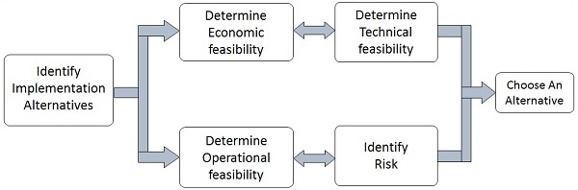

**Types of Feasibilities**

**Economic Feasibility**

* It is evaluating the effectiveness of candidate system by using cost/benefit analysis method.
* It demonstrates the net benefit from the candidate system in terms of benefits and costs to the organization.
* The main aim of Economic Feasibility Analysis (EFS) is to estimate the economic requirements of candidate system before investments funds are committed to proposal.
* It prefers the alternative which will maximize the net worth of organization by earliest and highest return of funds along with lowest level of risk involved in developing the candidate system.

**Technical Feasibility**

* It investigates the technical feasibility of each implementation alternative.
* It analyzes and determines whether the solution can be supported by existing technology or not.
* The analyst determines whether current technical resources be upgraded or added it that fulfill the new requirements.
* It ensures that the candidate system provides appropriate responses to what extent it can support the technical enhancement.

**Operational Feasibility**

* It determines whether the system is operating effectively once it is developed and implemented.
* It ensures that the management should support the proposed system and its working feasible in the current organizational environment.
* It analyzes whether the users will be affected and they accept the modified or new business methods that affect the possible system benefits.
* It also ensures that the computer resources and network architecture of candidate system are workable.

**Behavioral Feasibility**

* It evaluates and estimates the user attitude or behavior towards the development of new system.
* It helps in determining if the system requires special effort to educate, retrain, transfer, and changes in employee’s job status on new ways of conducting business.

**Schedule Feasibility**

* It ensures that the project should be completed within given time constraint or schedule.
* It also verifies and validates whether the deadlines of project are reasonable or not.

**4. SYSTEM DESIGN**

**System design** is the phase that bridges the gap between problem domain and the existing system in a manageable way. This phase focuses on the solution domain, i.e. *“how to implement?”*

It is the phase where the SRS document is converted into a format that can be implemented and decides how the system will operate.

In this phase, the complex activity of system development is divided into several smaller sub-activities, which coordinate with each other to achieve the main objective of system development.

**Types of System Design**

**Logical Design**

Logical design pertains to an abstract representation of the data flow, inputs, and outputs of the system. It describes the inputs (sources), outputs (destinations), databases (data stores), procedures (data flows) all in a format that meets the user requirements.

**Physical Design**

Physical design relates to the actual input and output processes of the system. It focuses on how data is entered into a system, verified, processed, and displayed as output.

**Architectural Design**

It is also known as high level design that focuses on the design of system architecture. It describes the structure and behavior of the system. It defines the structure and relationship between various modules of system development process.

**Detailed Design**

It follows Architectural design and focuses on development of each module.

**Conceptual Data Modelling**

It is representation of organizational data which includes all the major entities and relationship. System analysts develop a conceptual data model for the current system that supports the scope and requirement for the proposed system.

**4.1** **Data Flow Diagram**

A data-flow diagram is a way of representing a flow of data through a [process](https://en.wikipedia.org/wiki/Process) or a system (usually an [information system](https://en.wikipedia.org/wiki/Information_system)). The DFD also provides information about the outputs and inputs of each entity and the process itself. A data-flow diagram has no control flow — there are no decision rules and no loops.

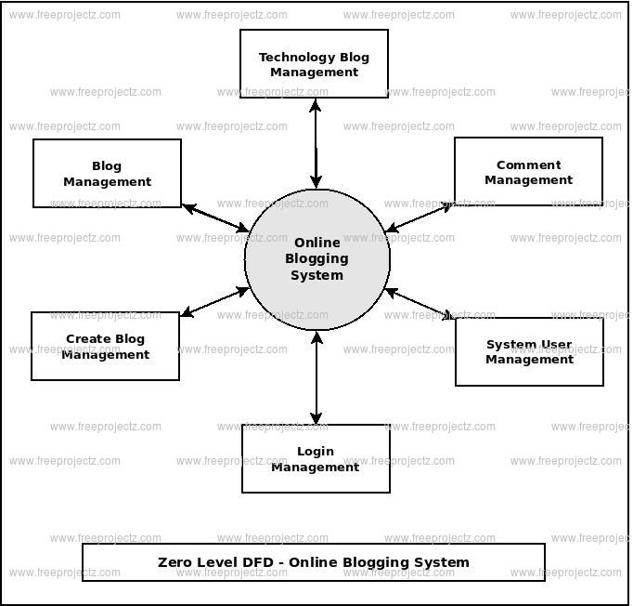

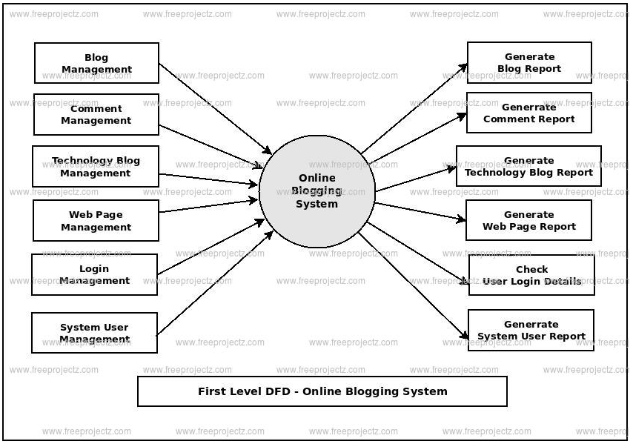

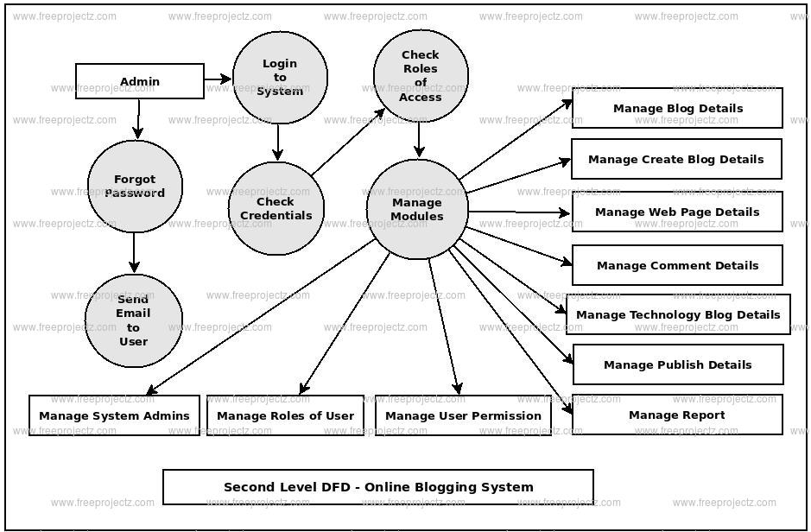

**4.2 ER Diagram**

Also called an entity-relationship model, a graphical representation of entities and their relationships to each other, typically used in computing in regard to the organization of data within databases or information systems. An entity is a piece of data—an object or concept about which data is stored. A relationship is how the data is shared between entities.

There are three basic elements in ER models:

* Entities are the "things" about which we seek information. Entity is represented by a rectangle.
* Attributes are the data we collect about the entities. Attribute is representing by an oval shape.
* Relationships provide the structure needed to draw information from multiple entities.

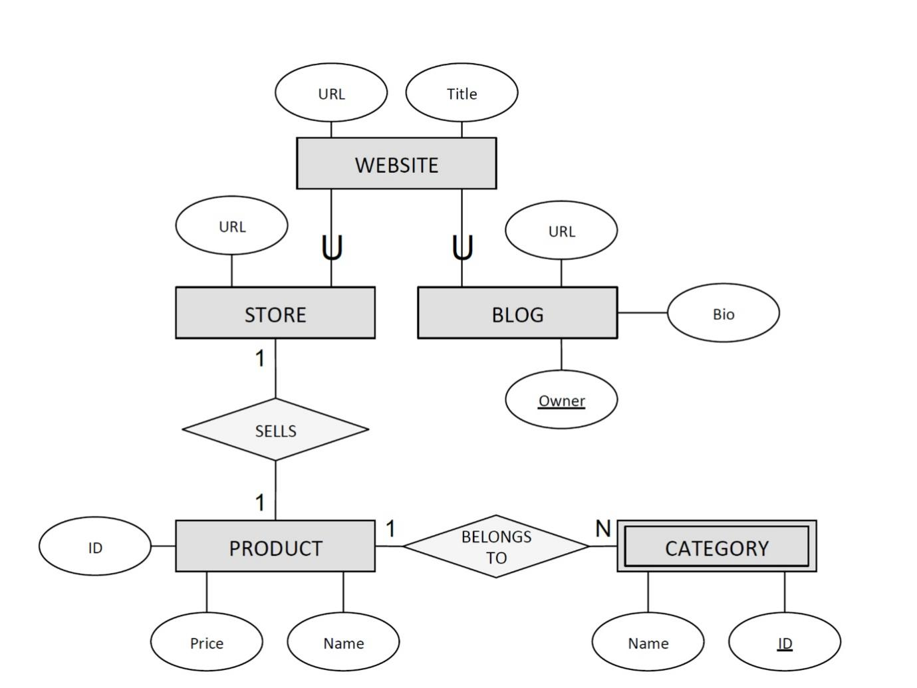

**4.3 Use Case Diagram**

A use case diagram is used to represent the dynamic behavior of a system. It encapsulates the system's functionality by incorporating use cases, actors, and their relationships. It models the tasks, services, and functions required by a system/subsystem of an application. It depicts the high-level functionality of a system and also tells how the user handles a system.

**Purpose of Use Case Diagrams**

The main purpose of a use case diagram is to portray the dynamic aspect of a system. It accumulates the system's requirement, which includes both internal as well as external influences. It invokes persons, use cases, and several things that invoke the actors and elements accountable for the implementation of use case diagrams. It represents how an entity from the external environment can interact with a part of the system.

Following are the purposes of a use case diagram given below:

1. It gathers the system's needs.
2. It depicts the external view of the system.
3. It recognizes the internal as well as external factors that influence the system.
4. It represents the interaction between the actors.

**4.4 Data Dictionary**

A data dictionary contains metadata i.e data about the database. The data dictionary is very important as it contains information such as what is in the database, who is allowed to access it, where is the database physically stored etc. The users of the database normally don't interact with the data dictionary, it is only handled by the database administrators.

The data dictionary in general contains information about the following −

* Names of all the database tables and their schemas.
* Details about all the tables in the database, such as their owners, their security constraints, when they were created etc.
* Physical information about the tables such as where they are stored and how.
* Table constraints such as primary key attributes, foreign key information etc.
* Information about the database views that are visible.

**Database**

**Notes**

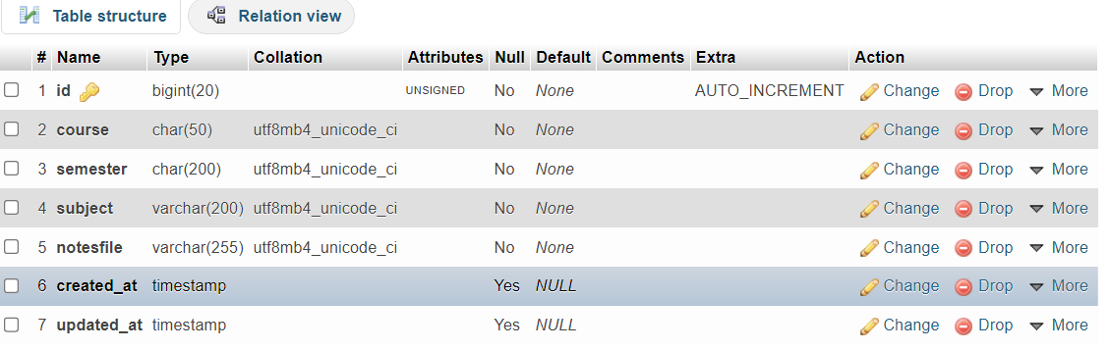

Indexes

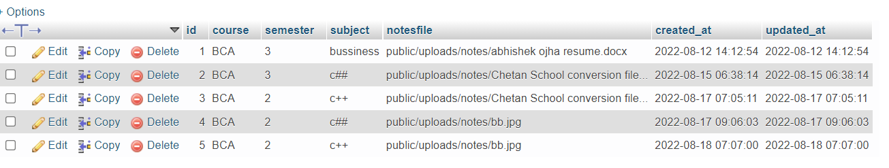

**Time-Table**

Columns

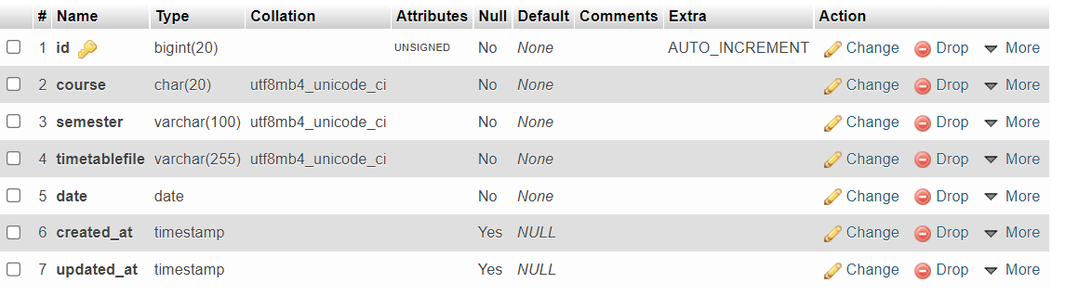

Indexes

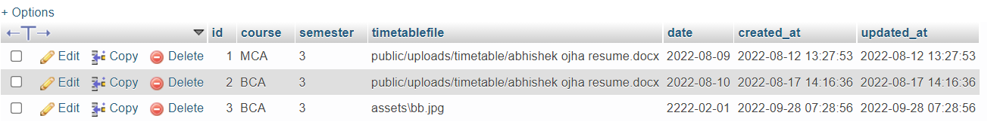

**syallabus**

**Columns**

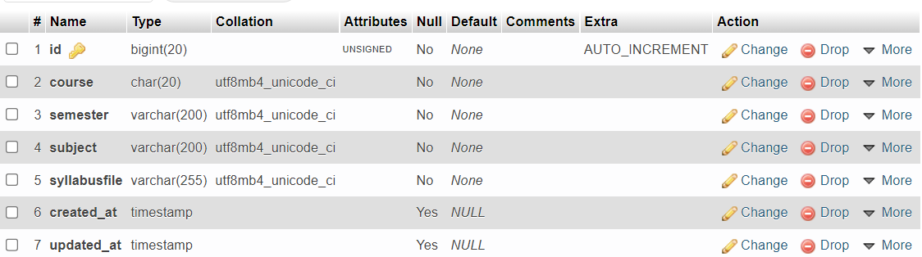

Indexes

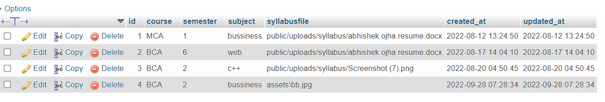

**Exampaper**

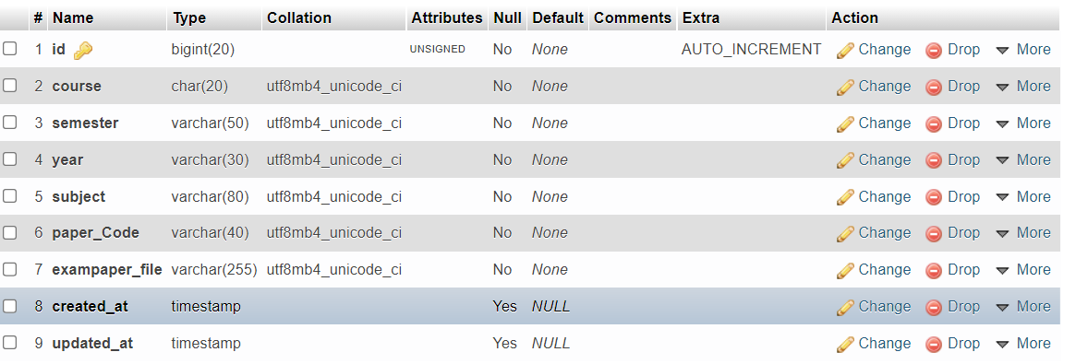

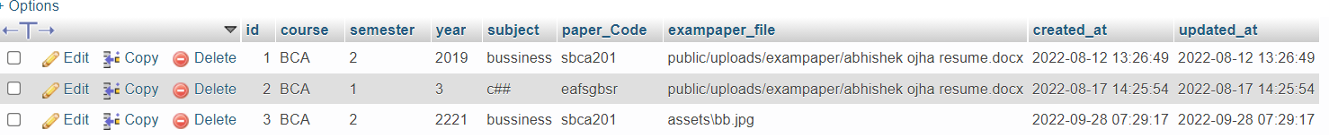

**Website Screenshot**

1. **Home Page**



1. **Funcational Page**

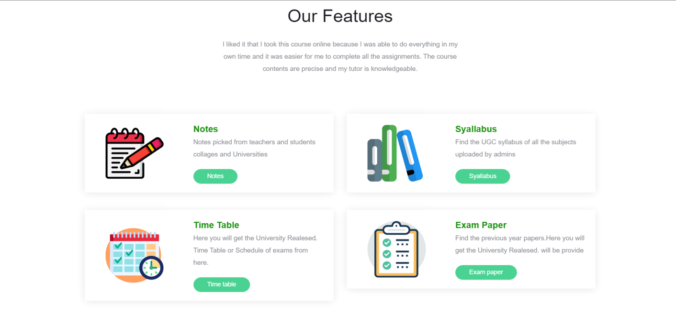

**3. Responsive icon Page**

**4. Contact Page**

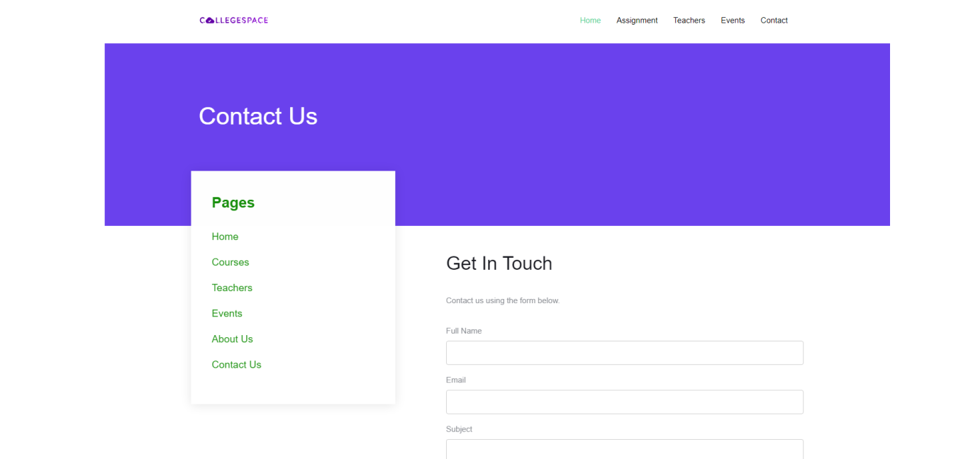

**5. About Page**



**6. chat box option**

Yaha par ye hata kar chat box ka laga dena

**7. Admin Login Page**

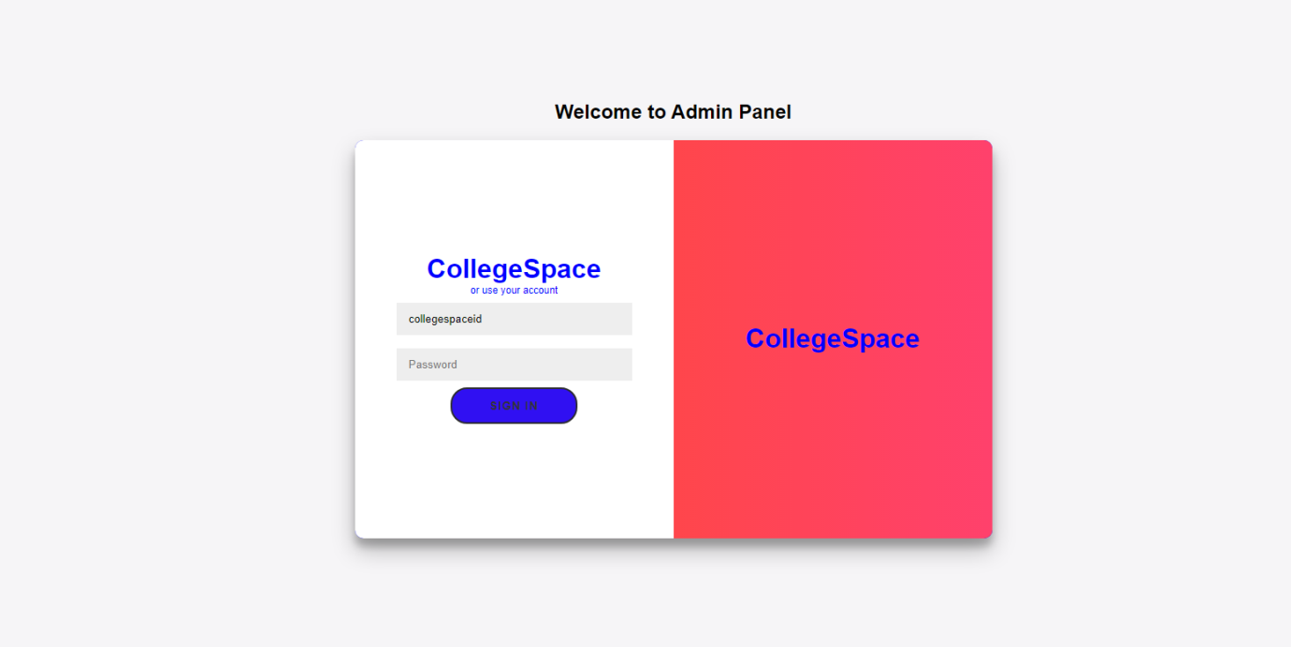

**8. Admin Panel**

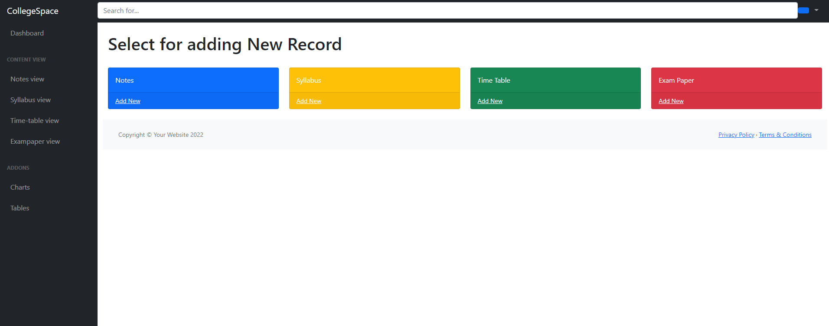

**Project Source Code**

1. **Home Page**

<!DOCTYPE html>

<html lang="en">

  <head>

      <div>

      @include('layout.header')

    </div>

  </head>

  <body>

    <div class="probootstrap-search" id="probootstrap-search">

      <a href="#" class="probootstrap-close js-probootstrap-close"><i class="icon-cross"></i></a>

      <form action="#">

        <input type="search" name="s" id="search" placeholder="Search a keyword and hit enter...">

      </form>

    </div>

    <div>

      @include('layout.navbar')

    </div>

      <section class="flexslider">

        <ul class="slides">

          <li style="background-image: url(img/slider18.jpg)" class="overlay">

            <div class="container">

              <div class="row">

                <div class="col-md-8 col-md-offset-2">

                  <div class="probootstrap-slider-text text-center">

                    <h1 class="probootstrap-heading probootstrap-animate">Your Bright Future is Our Mission</h1>

                  </div>

                </div>

              </div>

            </div>

          </li>

          <li style="background-image: url(img/slider100.jpg)" class="overlay">

            <div class="container">

              <div class="row">

                <div class="col-md-8 col-md-offset-2">

                  <div class="probootstrap-slider-text text-center">

                    <h1 class="probootstrap-heading probootstrap-animate">Education is Life</h1>

                  </div>

                </div>

              </div>

            </div>

          </li>

          <li style="background-image: url(img/img10.jpg)" class="overlay">

            <div class="container">

              <div class="row">

                <div class="col-md-8 col-md-offset-2">

                  <div class="probootstrap-slider-text text-center">

                    <h1 class="probootstrap-heading probootstrap-animate">Helping Each of Our Students Fulfill the Potential</h1>

                  </div>

                </div>

              </div>

            </div>

          </li>

        </ul>

      </section>

      {{-- about us --}}

      <section class="probootstrap-section probootstrap-section-colored">

        <div class="container">

          <div class="row">

            <div class="col-md-12 text-left section-heading probootstrap-animate">

              <h2>Welcome to College of Excellence</h2>

            </div>

          </div>

        </div>

      </section>

      <section class="probootstrap-section">

        <div class="container">

          <div class="row">

            <div class="col-md-12">

              <div class="probootstrap-flex-block">

                <div class="probootstrap-text probootstrap-animate">

                  <h3>About Us</h3>

                  <p>we provide every single piece of information about the student query

                    (exam schedules, admission schedule, admission merit lists, News, Events, and the notification slide for every day update ) in simple UI design.</p>

                  <p><a href="#" class="js-backtotop btn btn-primary">Learn More</a></p>

                </div>

                 <div class="probootstrap-image probootstrap-animate" style="background-image: url(img/col3.jpg)">

                  <a href="https://vimeo.com/45830194" class="btn-video popup-vimeo"><i class="icon-play3"></i></a>

                </div>

              </div>

            </div>

          </div>

        </div>

      </section>

      {{-- features --}}

      <section class="probootstrap-section probootstrap-bg-white probootstrap-border-top">

        <div class="container">

          <div class="row">

            <div class="col-md-6 col-md-offset-3 text-center section-heading probootstrap-animate">

              <h2>Our Features</h2>I liked it that I took this course online because I was able to do everything in my own time and it was easier for me to complete all the assignments. The course contents are precise and my tutor is knowledgeable.

              <p class="lead"></p>

            </div>

          </div>

*<!-- END row -->*

          <div class="row">

            <div class="col-md-6">

              <div class="probootstrap-service-2 probootstrap-animate">

                <div class="image">

                  <div class="image-bg">

                    <img src="img/notepad.png" alt="Free Bootstrap Template by ProBootstrap.com">

                  </div>

                </div>

                <div class="text">

                  <h3>Notes</h3>

                  <p>Notes picked from teachers and students  collages and Universities</p>

                  <p><a href="notes.show" class="btn btn-primary">Notes</a></p>

                </div>

              </div>

              <div class="probootstrap-service-2 probootstrap-animate">

                <div class="image">

                  <div class="image-bg">

                    <img src="img/timetable.png" alt="Free Bootstrap Template by ProBootstrap.com">

                  </div>

                </div>

                <div class="text">

                  <h3>Time Table</h3>

                  <p> Here you will get the University Realesed.

                    Time Table or Schedule of exams from here.</p>

                  <p><a href="timetable.show" class="btn btn-primary">Time table</a></p>

                </div>

              </div>

            </div>

            <div class="col-md-6">

              <div class="probootstrap-service-2 probootstrap-animate">

                <div class="image">

                  <div class="image-bg">

                    <img src="img/archive.png" alt="Free Bootstrap Template by ProBootstrap.com">

                  </div>

                </div>

                <div class="text">

                  <h3>Syallabus</h3>

                  <p>Find the UGC syllabus of all the subjects

                  uploaded by admins

                  </p>

                  <p><a href="syllabus.show" class="btn btn-primary">Syallabus</a></p>

                </div>

              </div>

              <div class="probootstrap-service-2 probootstrap-animate">

                <div class="image">

                  <div class="image-bg">

                    <img src="img/checklist.png" alt="Free Bootstrap Template by ProBootstrap.com">

                  </div>

                </div>

                <div class="text">

                  <h3>Exam Paper</h3>

                  <p>Find the previous year papers.Here you will get the University Realesed. will be provide</p>

                  <p><a href="exampaper.show" class="btn btn-primary">Exam paper</a></p>

                </div>

              </div>

            </div>

          </div>

        </div>

      </section>

      {{-- all number can counte --}}

      <section class="probootstrap-section" id="probootstrap-counter">

        <div class="container">

          <div class="row">

            <div class="col-md-3 col-sm-6 col-xs-6 col-xxs-12 probootstrap-animate">

              <div class="probootstrap-counter-wrap">

                <div class="probootstrap-icon">

                  <i class="icon-users2"></i>

                </div>

                <div class="probootstrap-text">

                  <span class="probootstrap-counter">

                    <span class="js-counter" data-from="0" data-to="20203" data-speed="5000" data-refresh-interval="50">1</span>

                  </span>

                  <span class="probootstrap-counter-label">Students Enrolled</span>

                </div>

              </div>

            </div>

            <div class="col-md-3 col-sm-6 col-xs-6 col-xxs-12 probootstrap-animate">

              <div class="probootstrap-counter-wrap">

                <div class="probootstrap-icon">

                  <i class="icon-user-tie"></i>

                </div>

                <div class="probootstrap-text">

                  <span class="probootstrap-counter">

                    <span class="js-counter" data-from="0" data-to="139" data-speed="5000" data-refresh-interval="50">1</span>

                  </span>

                  <span class="probootstrap-counter-label">Certified Teachers</span>

                </div>

              </div>

            </div>

            <div class="clearfix visible-sm-block visible-xs-block"></div>

            <div class="col-md-3 col-sm-6 col-xs-6 col-xxs-12 probootstrap-animate">

              <div class="probootstrap-counter-wrap">

                <div class="probootstrap-icon">

                  <i class="icon-library"></i>

                </div>

                <div class="probootstrap-text">

                  <span class="probootstrap-counter">

                    <span class="js-counter" data-from="0" data-to="99" data-speed="5000" data-refresh-interval="50">1</span>%

                  </span>

                  <span class="probootstrap-counter-label">Passing to Universities</span>

                </div>

              </div>

            </div>

            <div class="col-md-3 col-sm-6 col-xs-6 col-xxs-12 probootstrap-animate">

               <div class="probootstrap-counter-wrap">

                <div class="probootstrap-icon">

                  <i class="icon-smile2"></i>

                </div>

                <div class="probootstrap-text">

                  <span class="probootstrap-counter">

                    <span class="js-counter" data-from="0" data-to="100" data-speed="5000" data-refresh-interval="50">1</span>%

                  </span>

                  <span class="probootstrap-counter-label">Parents Satisfaction</span>

                </div>

              </div>

            </div>

          </div>

        </div>

      </section>

      {{-- highlight --}}

      <section class="probootstrap-section probootstrap-bg probootstrap-section-colored probootstrap-testimonial" style="background-image: url(img/slider_4.jpg);">

        <div class="container">

          <div class="row">

            <div class="col-md-6 col-md-offset-3 text-center section-heading probootstrap-animate">

              <h2>Student Reviews</h2>

              <p class="lead">Loved every minue studying and gained great knowledge. Looking forward to life as a life coach and being part of changing lives for the better.</p>

            </div>

          </div>

*<!-- END row -->*

          <div class="row">

            <div class="col-md-12 probootstrap-animate">

              <div class="owl-carousel owl-carousel-testimony owl-carousel-fullwidth">

                <div class="item">

                  <div class="probootstrap-testimony-wrap text-center">

                    <figure>

                      <img src="img/person_1.jpg" alt="Free Bootstrap Template by ProBootstrap.com">

                    </figure>

                    <blockquote class="quote">&ldquo;All notes were easy to read, and I found the homework challenging, but not impossible. I enjoyed researching! Very good. Lots of feedback!&rdquo; <cite class="author"> &mdash; <span>Mohit</span></cite></blockquote>

                  </div>

                </div>

                <div class="item">

                  <div class="probootstrap-testimony-wrap text-center">

                    <figure>

                      <img src="img/person_2.jpg" alt="Free Bootstrap Template by ProBootstrap.com">

                    </figure>

                    <blockquote class="quote">&ldquo;be honest you cannot beat the services or the people that I have dealt with. I loved the business management course. I rely on what I have learnt in my course often.&rdquo; <cite class="author"> &mdash;<span> Ramesh</span></cite></blockquote>

                  </div>

                </div>

                <div class="item">

                  <div class="probootstrap-testimony-wrap text-center">

                    <figure>

                      <img src="img/person_3.jpg" alt="Free Bootstrap Template by ProBootstrap.com">

                    </figure>

                    <blockquote class="quote">&ldquo;I would like to thank you for the helpful guidance pro

                      vided by the tutorial department. I am happy with my tutor who is very efficient and s

                      hared his knowledge and experience with me.&rdquo; <cite class="author">&mdash; <span>Mohammed</span></cite></blockquote>

                  </div>

                </div>

              </div>

            </div>

          </div>

*<!-- END row -->*

        </div>

      </section>

      <section class="probootstrap-section">

        <div class="container">

          <div class="row">

            <div class="col-md-6 col-md-offset-3 text-center section-heading probootstrap-animate">

              <h2>Why Choose CollegeSpace</h2>

              <p class="lead">We only focused on helping innocent students with there doubts.</p>

            </div>

          </div>

          <div class="row">

            <div class="col-md-6">

              <div class="service left-icon probootstrap-animate">

                <div class="icon"><i class="icon-checkmark"></i></div>

                <div class="text">

                  <h3>Providing Note</h3>

                  <p>Notes picked from teachers and students from respected collages and Universities</p>

                </div>

              </div>

              <div class="service left-icon probootstrap-animate">

                {{-- <div class="icon"><i class="icon-checkmark"></i></div>

                <div class="text">

                  <h3>Relivent Syallabus</h3>

                  <p>very structure form of Sysllabus uploaded by teachers and admins </p>

                </div> --}}

              </div>

              <div class="service left-icon probootstrap-animate">

                <div class="icon"><i class="icon-checkmark"></i></div>

                <div class="text">

                  <h3>Student Support </h3>

                  <p>Lorem ipsum dolor sit amet consectetur adipisicing elit. Iusto provident qui tempore natus quos quibusdam soluta at.</p>

                </div>

              </div>

            </div>

            <div class="col-md-6">

              <div class="service left-icon probootstrap-animate">

                <div class="icon"><i class="icon-checkmark"></i></div>

                <div class="text">

                  <h3>Time Table</h3>

                  <p>Lorem ipsum dolor sit amet consectetur adipisicing elit. Iusto provident qui tempore natus quos quibusdam soluta at.</p>

                </div>

              </div>

              <div class="service left-icon probootstrap-animate">

                <div class="icon"><i class="icon-checkmark"></i></div>

                <div class="text">

                  <h3>Exam Paper</h3>

                  <p>Lorem ipsum dolor sit amet consectetur adipisicing elit. Iusto provident qui tempore natus quos quibusdam soluta at.</p>

                </div>

              </div>

              <div class="service left-icon probootstrap-animate">

                {{-- <div class="icon"><i class="icon-checkmark"></i></div>

                <div class="text">

                  <h3>Libero Maxime Molestiae</h3>

                  <p>Lorem ipsum dolor sit amet consectetur adipisicing elit. Iusto provident qui tempore natus quos quibusdam soluta at.</p>

                </div> --}}

              </div>

            </div>

          </div>

*<!-- END row -->*

        </div>

      </section>

      <section class="probootstrap-cta">

        <div class="container">

          <div class="row">

            <div class="col-md-12">

              <h2 class="probootstrap-animate" data-animate-effect="fadeInRight">Get your admission now!</h2>

              <a href="#" role="button" class="btn btn-primary btn-lg btn-ghost probootstrap-animate" data-animate-effect="fadeInLeft">Enroll</a>

            </div>

          </div>

        </div>

      </section>

    <footer>

      <div>

      @include('layout.footer')

      </div>

    </footer>

    </div>

*<!-- END wrapper -->*

    <script src="js/scripts.min.js"></script>

    <script src="js/main.min.js"></script>

    <script src="js/custom.js"></script>

    <script src="js/tawk.js"></script>

  </body>

</html>

1. **Notes Page**

<!DOCTYPE html>

<html lang="en">

<head>

    <meta charset="UTF-8">

    <meta http-equiv="X-UA-Compatible" content="IE=edge">

    <meta name="viewport" content="width=device-width, initial-scale=1.0">

    <title>Document</title>

    <div>

      @include('layout.header')

    </div>

    <style>

    .table{

        width:50%;

        margin-left:auto;

        margin-right:auto;

    }

    </style>

</head>

<body>

<for

<div>

      @include('layout.navbar')

    </div>

    <table class ="table text-center" border="4">

    <tr>

        <th>course</th>

        <th>Semester</th>

        <th>subject</th>

        <th>Notes Download</th>

         </tr>

         @foreach ($notes as $notes)

         <tr>

                            <td>{{$notes->course}}</td>

                            <td>{{$notes->semester}}</td>

                        <td>{{$notes->subject}}</td>

                        <td><a href="{{url('/download',$notes->notesfile)}}" >Download</a></td>

                        </tr>

                        @endforeach

        </table>

        <div>

      @include('layout.footer')

    </div>

</body>

</html>

1. **Syllabus Page**
2. <!DOCTYPE html>
3. <html lang="en">
4. <head>
5. <meta charset="UTF-8">
6. <meta http-equiv="X-UA-Compatible" content="IE=edge">
7. <meta name="viewport" content="width=device-width, initial-scale=1.0">
8. <title>Document</title>
9. <div>
10. @include('layout.header')
11. </div>
12. <style>
13. .table{
14. width:50%;
15. margin-left:auto;
16. margin-right:auto;
17. }
18. </style>
19. </head>
20. <body>
21. <div>
22. @include('layout.navbar')
23. </div>
24. <table class ="table text-center" border="4">
25. <tr>
27. <th>course</th>
28. <th>Semester</th>
29. <th>subject</th>
30. <th>Syllabus Download</th>
32. </tr>
33. @foreach ($syllabus as $syllabus)
34. <tr>
36. <td>{{$syllabus->course}}</td>
37. <td>{{$syllabus->semester}}</td>
38. <td>{{$syllabus->subject}}</td>
40. <td><a href="{{url('/download', $syllabus->syllabusfile)}}" >Download </a></td>
41. </tr>
42. @endforeach
43. </table>
44. <div>
45. @include('layout.footer')
46. </div>
47. </body>
48. </html>

**4. Time-Table Page**

1. <!DOCTYPE html>
2. <html lang="en">
3. <head>
4. <meta charset="UTF-8">
5. <meta http-equiv="X-UA-Compatible" content="IE=edge">
6. <meta name="viewport" content="width=device-width, initial-scale=1.0">
7. <title>Document</title>
8. <div>
9. @include('layout.header')
10. </div>
11. <style>
12. .table{
13. width:50%;
14. margin-left:auto;
15. margin-right:auto;
16. }
17. </style>
18. </head>
19. <body>
20. <div>
21. @include('layout.navbar')
22. </div>
23. <table class ="table text-center" border="4">
24. <div>
25. <tr>
26. <th>course</th>
27. <th>Semester</th>
28. <th>date</th>
29. <th>timetable Download</th>
31. </tr>
32. @foreach ($timetable as $timetable)
33. <tr>
34. <td>{{$timetable->course}}</td>
35. <td>{{$timetable->semester}}</td>
36. <td>{{$timetable->date}}</td>
38. <td><a href="{{url('/download', $timetable->timetablefile)}}">Download</a></td>
39. </tr>
40. @endforeach
41. </table>
42. </div>
43. <div>
44. @include('layout.footer')
45. </div>
46. </body>
47. </html>

**5. Exampaper Page**

<!DOCTYPE html>

<html lang="en">

<head>

    <meta charset="UTF-8">

    <meta http-equiv="X-UA-Compatible" content="IE=edge">

    <meta name="viewport" content="width=device-width, initial-scale=1.0">

    <title>Document</title>

    <div>

      @include('layout.header')

    </div>

    <style>

    .table{

        width:50%;

        margin-left:auto;

        margin-right:auto;

    }

    </style>

</head>

<body>

<div>

      @include('layout.navbar')

    </div>

    <table class ="table text-center" border="4">

    <tr>

        <th>course</th>

        <th>Semester</th>

        <th>year</th>

        <th>subject</th>

        <th>Paper code</th>

        <th>Exam-paper Download</th>

         </tr>

         @foreach ($exampaper as $exampaper)

         <tr>

                            <td>{{$exampaper->course}}</td>

                            <td>{{$exampaper->semester}}</td>

                            <td>{{$exampaper->year}}</td>

                        <td>{{$exampaper->subject}}</td>

                        <td>{{$exampaper->paper_Code}}</td>

                        <td><a href="{{url('/download', $exampaper->exampaper_file)}}">Download</a></td>

                        </tr>

                        @endforeach

        </table>

        <div>

      @include('layout.footer')

    </div>

</body>

</html>

**6. Admin Page**

<!DOCTYPE html>

<html lang="en">

    <head>

        <meta charset="utf-8" />

        <meta http-equiv="X-UA-Compatible" content="IE=edge" />

        <meta name="viewport" content="width=device-width, initial-scale=1, shrink-to-fit=no" />

        <meta name="description" content="" />

        <meta name="author" content="" />

        <link href="https://cdn.jsdelivr.net/npm/simple-datatables@latest/dist/style.css" rel="stylesheet" />

<body class="sb-nav-fixed">

        <nav class="sb-topnav navbar navbar-expand navbar-dark bg-dark">

*<!-- Navbar Brand-->*

            <a class="navbar-brand ps-3" href="index.html">CollegeSpace</a>

*<!-- Sidebar Toggle-->*

            <button class="btn btn-link btn-sm order-1 order-lg-0 me-4 me-lg-0" id="sidebarToggle" href="#!"><i class="fas fa-bars"></i></button>

*<!-- Navbar Search-->*

            <form class="d-none d-md-inline-block form-inline ms-auto me-0 me-md-3 my-2 my-md-0">

                <div class="input-group">

                </div>

            </form>

*<!-- Navbar-->*

                    <input class="form-control" type="text" placeholder="Search for..." aria-label="Search for..." aria-describedby="btnNavbarSearch" />

                    <button class="btn btn-primary" id="btnNavbarSearch" type="button"><i class="fas fa-search"></i></button>

                </div>

            </form>

*<!-- Navbar-->*

            <ul class="navbar-nav ms-auto ms-md-0 me-3 me-lg-4">

                <li class="nav-item dropdown">

                    <a class="nav-link dropdown-toggle" id="navbarDropdown" href="#" role="button" data-bs-toggle="dropdown" aria-expanded="false"><i class="fas fa-user fa-fw"></i></a>

                    <ul class="dropdown-menu dropdown-menu-end" aria-labelledby="navbarDropdown">

                        <li><a class="dropdown-item" href="#!">Settings</a></li>

                        <li><a class="dropdown-item" href="#!">Activity Log</a></li>

                        <li><hr class="dropdown-divider" /></li>

                        <li><a class="dropdown-item" href="{{url('/login')}}">Logout</a></li>

                    </ul>

                </li>

            </ul>

        </nav>

        <div id="layoutSidenav">

            <div id="layoutSidenav_nav">

                <nav class="sb-sidenav accordion sb-sidenav-dark" id="sidenavAccordion">

                    <div class="sb-sidenav-menu">

                        <div class="nav">

                            <a class="nav-link" href="index.html">

                                <div class="sb-nav-link-icon"><i class="fas fa-tachometer-alt"></i></div>

                                Dashboard

                            </a>

                            <div class="sb-sidenav-menu-heading">Content view</div>

                            <a class="nav-link collapsed" href="{{route('notes.view')}}" >

                                <div class="sb-nav-link-icon"><i class="fas fa-columns"></i></div>

                                Notes view

                                <div class="sb-sidenav-collapse-arrow"><i class="fas fa-angle-down"></i></div>

                            </a>

                            <a class="nav-link collapsed" href="{{route('syllabus.view')}}"  >

                                <div class="sb-nav-link-icon"><i class="fas fa-columns"></i></div>

                               Syllabus view

                                <div class="sb-sidenav-collapse-arrow"><i class="fas fa-angle-down"></i></div>

                            </a>

                            <a class="nav-link collapsed" href="{{route('timetable.view')}}" >

                                <div class="sb-nav-link-icon"><i class="fas fa-columns"></i></div>

                                Time-table view

                                <div class="sb-sidenav-collapse-arrow"><i class="fas fa-angle-down"></i></div>

                            </a>

                            <a class="nav-link collapsed" href="{{route('exampaper.view')}}" >

                                <div class="sb-nav-link-icon"><i class="fas fa-columns"></i></div>

                                Exampaper view

                                <div class="sb-sidenav-collapse-arrow"><i class="fas fa-angle-down"></i></div>

                            </a>

                            <div class="collapse" id="collapsePages" aria-labelledby="headingTwo" data-bs-parent="#sidenavAccordion">

                                <nav class="sb-sidenav-menu-nested nav accordion" id="sidenavAccordionPages">

                                    <a class="nav-link collapsed" href="#" data-bs-toggle="collapse" data-bs-target="#pagesCollapseAuth" aria-expanded="false" aria-controls="pagesCollapseAuth">

                                        Authentication

                                        <div class="sb-sidenav-collapse-arrow"><i class="fas fa-angle-down"></i></div>

                                    </a>

                                    <div class="collapse" id="pagesCollapseAuth" aria-labelledby="headingOne" data-bs-parent="#sidenavAccordionPages">

                                        <nav class="sb-sidenav-menu-nested nav">

                                            <a class="nav-link" href="login.html">Login</a>

                                            <a class="nav-link" href="register.html">Register</a>

                                            <a class="nav-link" href="password.html">Forgot Password</a>

                                        </nav>

                                    </div>

                                    <a class="nav-link collapsed" href="#" data-bs-toggle="collapse" data-bs-target="#pagesCollapseError" aria-expanded="false" aria-controls="pagesCollapseError">

                                        Error

                                        <div class="sb-sidenav-collapse-arrow"><i class="fas fa-angle-down"></i></div>

                                    </a>

                                    <div class="collapse" id="pagesCollapseError" aria-labelledby="headingOne" data-bs-parent="#sidenavAccordionPages">

                                        <nav class="sb-sidenav-menu-nested nav">

                                            <a class="nav-link" href="401.html">401 Page</a>

                                            <a class="nav-link" href="404.html">404 Page</a>

                                            <a class="nav-link" href="500.html">500 Page</a>

                                        </nav>

                                    </div>

                                </nav>

                            </div>

                            <div class="sb-sidenav-menu-heading">Addons</div>

                            <a class="nav-link" href="charts.html">

                                <div class="sb-nav-link-icon"><i class="fas fa-chart-area"></i></div>

                                Charts

                            </a>

                            <a class="nav-link" href="tables.html">

                                <div class="sb-nav-link-icon"><i class="fas fa-table"></i></div>

                                Tables

                            </a>

                        </div>

                    </div>

                </nav>

            </div>

            <div id="layoutSidenav_content">

                <main>

                    <div class="container-fluid px-4">

                        <h1 class="mt-4">Select for adding New Record</h1>

                        <ol class="breadcrumb mb-4">

                            <li class="breadcrumb-item active"></li>

                        </ol>

                        <div class="row">

                            <div class="col-xl-3 col-md-6">

                                <div class="card bg-primary text-white mb-4">

                                    <div class="card-body">Notes </div>

                                    <div class="card-footer d-flex align-items-center justify-content-between">

                                        <a class="small text-white stretched-link" href="{{route('notes.form')}}">Add New</a>

                                    </div>

                                </div>

                            </div>

                            <div class="col-xl-3 col-md-6">

                                <div class="card bg-warning text-white mb-4">

                                    <div class="card-body">Syllabus</div>

                                    <div class="card-footer d-flex align-items-center justify-content-between">

                                        <a class="small text-white stretched-link" href="{{route('syllabus.form')}}">Add New</a>

                                </div>

                            </div>

                            </div>

                            <div class="col-xl-3 col-md-6">

                                <div class="card bg-success text-white mb-4">

                                    <div class="card-body">Time Table</div>

                                    <div class="card-footer d-flex align-items-center justify-content-between">

                                        <a class="small text-white stretched-link" href="{{route('timetable.form')}}">Add New</a>

                                        </div>

                                    </div>

                                </div>

                            <div class="col-xl-3 col-md-6">

                                <div class="card bg-danger text-white mb-4">

                                    <div class="card-body">Exam Paper</div>

                                    <div class="card-footer d-flex align-items-center justify-content-between">

                                        <a class="small text-white stretched-link" href="{{route('exampaper.form')}}">Add New</a>

                                </div>

                            </div>

                        </div>

                <footer class="py-4 bg-light mt-auto">

                    <div class="container-fluid px-4">

                        <div class="d-flex align-items-center justify-content-between small">

                            <div class="text-muted">Copyright &copy; Your Website 2022</div>

                            <div>

                                <a href="#">Privacy Policy</a>

                                &middot;

                                <a href="#">Terms &amp; Conditions</a>

                            </div>

                        </div>

                    </div>

                </footer>

            </div>

        </div>

        <script src="https://cdn.jsdelivr.net/npm/bootstrap@5.1.3/dist/js/bootstrap.bundle.min.js" crossorigin="anonymous"></script>

        <script src="js/scripts.js"></script>

        <script src="https://cdnjs.cloudflare.com/ajax/libs/Chart.js/2.8.0/Chart.min.js" crossorigin="anonymous"></script>

        <script src="assets/demo/chart-area-demo.js"></script>

        <script src="assets/demo/chart-bar-demo.js"></script>

        <script src="https://cdn.jsdelivr.net/npm/simple-datatables@latest" crossorigin="anonymous"></script>

        <script src="js/datatables-simple-demo.js"></script>

    </body>

</html>

**5. MECHANISMS USED**

Testing is the process of executing a program with the aim of finding errors. To make our software perform well it should be error-free. If testing is done successfully it will remove all the errors from the software.

**Principles of Testing:-**

1. All the test should meet the customer requirements
2. To make our software testing should be performed by a third party
3. Exhaustive testing is not possible. As we need the optimal amount of testing based on the risk assessment of the application.
4. All the test to be conducted should be planned before implementing it
5. It follows the Pareto rule (80/20 rule) which states that 80% of errors come from 20% of program components.
6. Start testing with small parts and extend it to large parts.

**5.1 Testing Mechanisms**

**1. Unit Testing**

It focuses on the smallest unit of software design. In this, we test an individual unit or group of interrelated units. It is often done by the programmer by using sample input and observing its corresponding outputs. 

Example:

In **College Space** website, I checked if pricing calculator was working correctly in Quote and removed any errors that occurred.

**2. Integration Testing**

The objective is to take unit tested components and build a program structure that has been dictated by design. Integration testing is testing in which a group of components is combined to produce output.

Integration testing is of four types: (i) Top-down (ii) Bottom-up (iii) Sandwich (iv) Big-Bang   
Example:

(a) **Black Box testing**:- It is used for validation. In this we ignore internal working mechanism and focus on **what is the output?**

(b) **White Box testing**:- It is used for verification. In this we focus on internal mechanism i.e. **how the output is achieved?**

**3. Regression Testing**

Every time a new module is added leads to changes in the program. This type of testing makes sure that the whole component works properly even after adding components to the complete program.   
Example:

In **College Space**, I checked the complete website every time a new module was added like Quote, Courier details and Checkout.

**4. Smoke Testing**

This test is done to make sure that software under testing is ready or stable for further testing.   
It is called a smoke test as the testing an initial pass is done to check if it did not catch the fire or smoke in the initial switch on.   
Example:

Before testing Checkout system on **College Space** I made sure Customer details form was working without any bugs.

**5. Alpha Testing**

This is a type of validation testing. It is a type of *acceptance testing*which is done before the product is released to customers. It is typically done by QA people.   
Example:

I checked complete **College Space** website beforehand for any bugs and errors before it was released to public.

**6. Beta Testing**

The beta test is conducted at one or more customer sites by the end-user of the software. This version is released for a limited number of users for testing in a real-time environment   
Example:

**College Space** website was run and tested by 4 people who were end users of the application.

**7. System Testing**

This software is tested such that it works fine for the different operating systems. It is covered under the black box testing technique. In this, we just focus on the required input and output without focusing on internal working.   
In this, we have security testing, recovery testing, stress testing, and performance testing   
Example:

**College Space** was tested on different browsers with different inputs and outputs.

**8. Stress Testing**

In this, we give unfavorable conditions to the system and check how they perform in those conditions.   
Example:

**College Space** was tested with large inputs to test it’s working.

**9. Performance Testing**

It is designed to test the run-time performance of software within the context of an integrated system. It is used to test the speed and effectiveness of the program. It is also called load testing. In it we check, what is the performance of the system in the given load.  
Example:   
 Checking number of processor cycles in College Space.

**6. Future Scope of the Project**

College Space was created on a small scale to serve as a major project for BCA 6th Semester and it has the potential to become a information providing info blog for University. It provides assured, Correct Information on time

We are also planning to add popup notification on our site Through which Students and users can get information more Frequently.

**7. Bibliography and reference**

We took the reference of Mr. Jitesh Jain . The books we used as a references are Harvey M.Dietel , Paul Dietel & Tem R. Nieto, “,Internet &World Wide web How to program ”, Pearson, 2011, Ivan Bayross. “Web enabled commercial application development using HTML, DHTML ,Javascript, PERL-CGI”, BPB publications, 2010 and Mobile communications.

[www.w3school.com](http://www.w3school.com)

[www.google.com](http://www.google.com)

[www.stackoverflow.com](http://www.stackoverflow.com)